## Web Technologies Lab Manual as per JNTUK-R16

### REGISTRATION PAGE:

**EXPERIMENT-4**

Create a “*registration form* “with the following fields



* 1. Name (Text field)
  2. Password (password field)
  3. E-mail id (text field)
  4. Phone number (text field)
  5. Sex (radio button)
  6. Date of birth (3 select boxes)
  7. Languages known (check boxes – English, Telugu, Hindi, Tamil)
  8. Address (text area)

### registration.html

<html>

<head>

<title>Registration Page</title>

</head>

<body>

<center>

<h3 align="center"><u>REGISTRATION PAGE</u></h3>

<table border="3">

<tr><td>

<form name="f1" action="" method="post" onsubmit="">

<table cellspacing="10" cellpadding="5">

<tr><td>NAME</td><td><input type="text" size="30" name="uname"/></td></tr>

<tr><td>PASSWORD</td><td><input type="password" size="30" name="pass"/></td></tr>

<tr><td>E-MAIL ID</td><td><input type="text" size="30" name="email"/></td></tr>

<tr><td> PHONE NUMBER</td><td><input type="text" size="15" name="phone"/></td></tr>

<tr><td>GENDER</td><td><input type="radio" name="gen" value="m" />MALE

<input type="radio" name="gen" value="f" />FEMALE </td></tr>

<tr><td>DATE OF BIRTH</td>

<td><select name="day">

<option value="day">DAY</option>

<option value="1">1</option>

<option value="2">2</option>

<option value="3">3</option>

<option value="4">4</option>

<option value="5">5</option>

<option value="6">6</option>

<option value="7">7</option>

<option value="8">8</option>

<option value="9">9</option>

<option value="10">10</option>

<option value="11">11</option>

<option value="12">12</option>

<option value="13">13</option>

<option value="14">14</option>

<option value="15">15</option>

<option value="16">16</option>

<option value="17">17</option>

<option value="18">18</option>

<option value="19">19</option>

<option value="20">20</option>

<option value="21">21</option>

<option value="22">22</option>

<option value="23">23</option>

<option value="24">24</option>

<option value="25">25</option>

<option value="26">26</option>

<option value="27">27</option>

<option value="28">28</option>

<option value="29">29</option>

<option value="30">30</option>

<option value="31">31</option>

</select>

<select name="month">

<option value="month">MONTH</option>

<option value="jan">JANUARY</option>

<option value="feb">FEBRUARY</option>

## Web Technologies Lab Manual as per JNTUK-R16



<option value="mar">MARCH</option>

<option value="apr">APRIL</option>

<option value="may">MAY</option>

<option value="jun">JUNE</option>

<option value="jul">JULY</option>

<option value="aug">AUGUST</option>

<option value="sep">SEPTEMBER</option>

<option value="oct">OCTOBER</option>

<option value="nov">NOVEMBER</option>

<option value="dec">DECEMBER</option>

</select>

<select name="year">

<option value="year">YEAR</option>

<option value="1986">1986</option>

<option value="1987">1987</option>

<option value="1988">1988</option>

<option value="1989">1989</option>

<option value="1990">1990</option>

<option value="1991">1991</option>

<option value="1992">1992</option>

<option value="1993">1993</option>

<option value="1994">1994</option>

<option value="1995">1995</option>

<option value="1996">1996</option>

<option value="1997">1997</option>

<option value="1998">1998</option>

<option value="1999">1999</option>

<option value="2000">2000</option>

<option value="2001">2001</option>

<option value="2002">2002</option>

<option value="2003">2003</option>

<option value="2004">2004</option>

<option value="2005">2005</option>

<option value="2006">2006</option>

<option value="2007">2007</option>

<option value="2008">2008</option>

<option value="2009">2009</option>

<option value="2010">2010</option>

<option value="2011">1980</option>

<option value="2012">1981</option>

<option value="2013">1982</option>

<option value="2014">1983</option>

</select></td></tr>

<tr><td>LANGUAGES KNOWN</td>

<td>

<input type="checkbox" value="eng" name="lang" />ENGLISH

<input type="checkbox" value="tel" name="lang" />TELUGU

<input type="checkbox" value="hin" name="lang" />HINDI

<input type="checkbox" value="tam" name="lang" />TAMIL

</td></tr>

<tr>

<td>ADDRESS</td>

<td><textarea name="addr" cols="25" rows="5"></textarea></td></tr>

<tr><td colspan="2" align="center"><input type="submit" value="SUBMIT"/> &nbsp;&nbsp;&nbsp;&nbsp;&nbsp;&nbsp;<input type="reset" value="RESET" /></td>

</tr>

</table>

</form>

</td></tr></table>

</center>

</body>

</html>

## Web Technologies Lab Manual as per JNTUK-R16

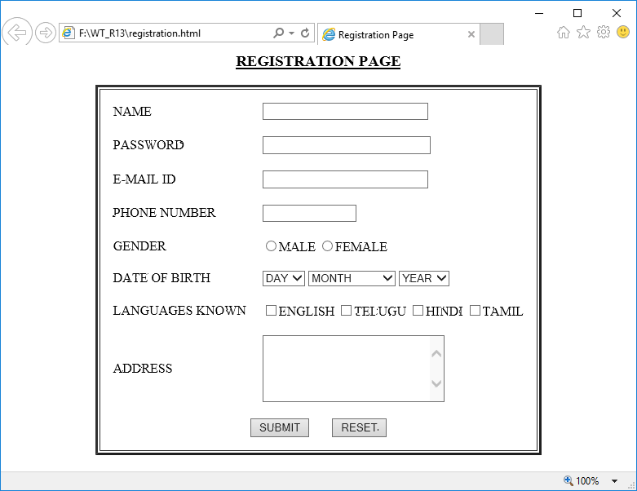

### OUTPUT: